Project Design Phase-II
Data Flow Diagram & User Stories
Date | 25 September 2026
Team ID
Project Name | Metro Ticket Generating System in ServiceNow
Maximum Marks | 4 Marks

Data Flow Diagrams:
A Data Flow Diagram (DFD) is a traditional visual representation of the information flows within a system. A neat and clear DFD can depict the right amount of the system requirement graphically. It shows how data enters and leaves the system, what changes the information, and where data is stored.
The Metro Ticket Generating System in ServiceNow is shown at two levels: Level 0 (context diagram) shows the system with its external entities, and Level 1 breaks it into its main processes and data stores.
DFD Level 0 – Context Diagram
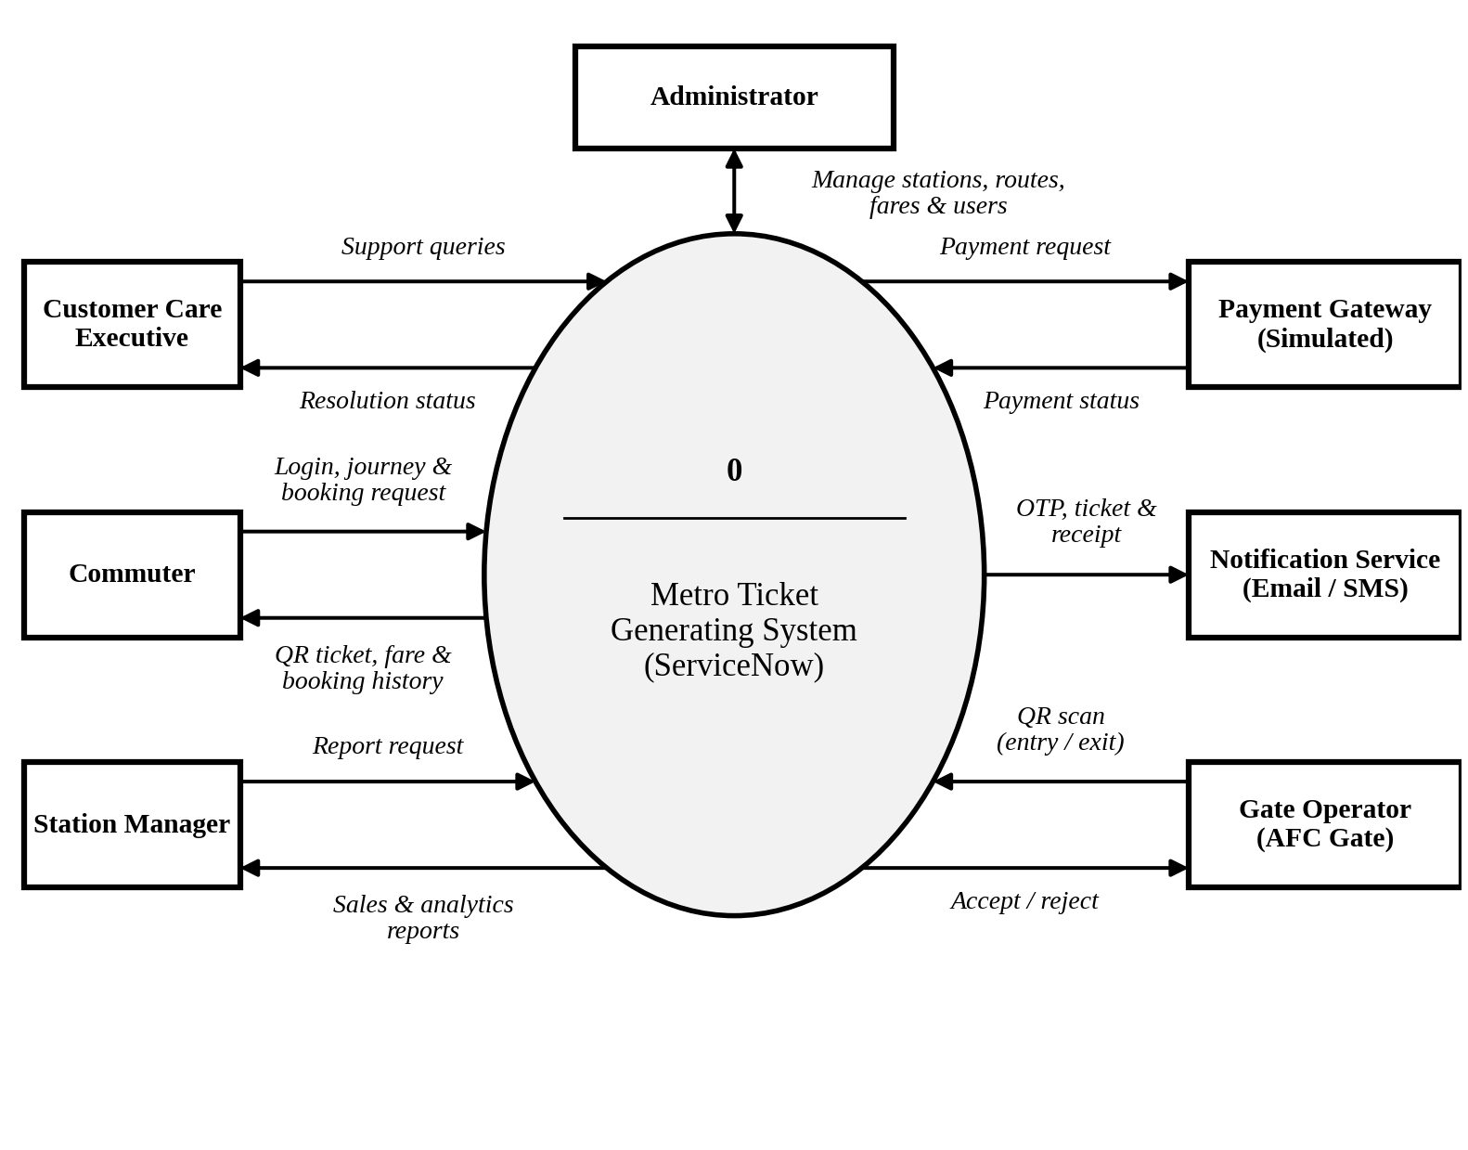
Figure 1: Data Flow Diagram – Level 0
The Commuter registers, books tickets and receives the QR ticket; the simulated Payment Gateway returns the payment status; the Notification Service delivers OTPs, tickets and receipts; the Gate Operator submits scanned QR codes; and staff users handle support, reports and administration.
DFD Level 1 – Part A: Registration, Booking, Payment and Ticket Generation
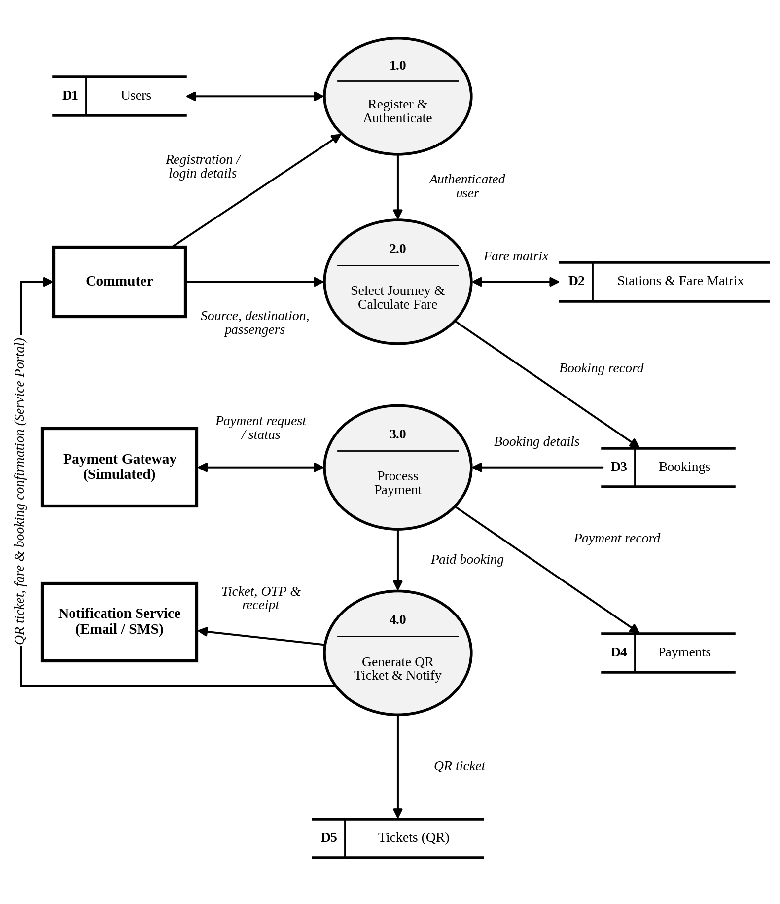
Figure 2: Data Flow Diagram – Level 1 (Processes 1.0 to 4.0)
ID | Process | Description
1.0 | Register & Authenticate User | Captures registration details, sends email / OTP confirmation, authenticates login and stores user data in D1.
2.0 | Select Journey & Calculate Fare | Accepts source, destination and passengers, reads the fare matrix (D2) and creates the booking record (D3).
3.0 | Process Payment | Sends the payment request to the simulated payment gateway, receives success / failure and stores the payment record (D4).
4.0 | Generate QR Ticket & Notify | Generates a unique QR ticket after payment, stores it in D5, sends the ticket and receipt through the Notification Service and shows it to the commuter in the Service Portal.
DFD Level 1 – Part B: Gate Validation and Reporting
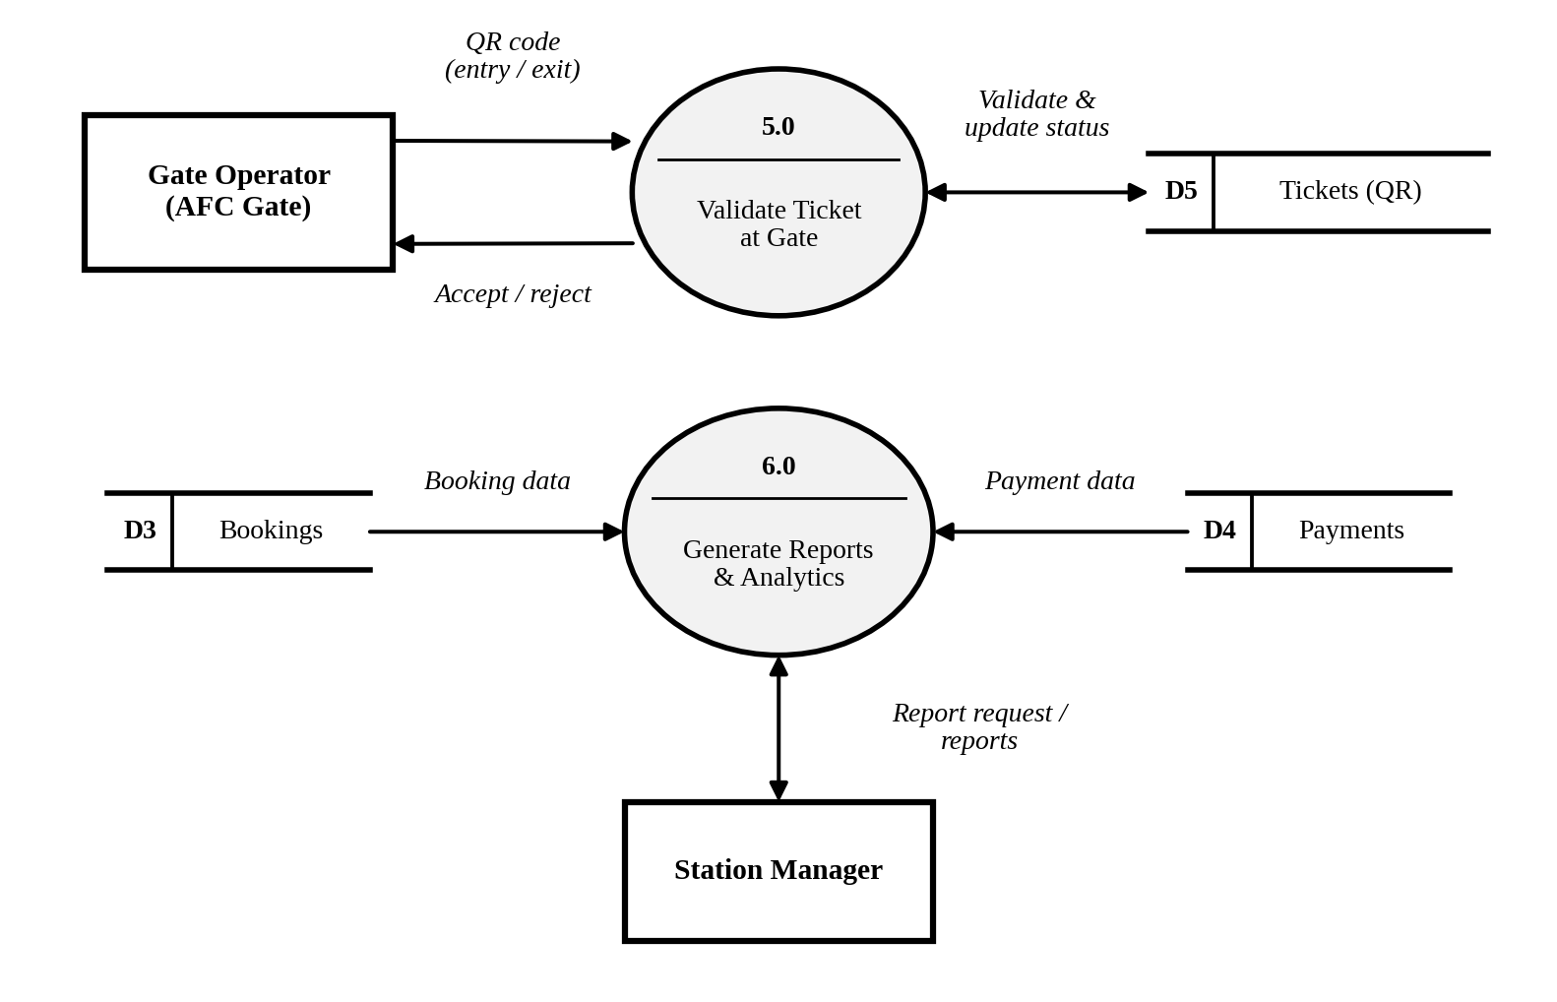
Figure 3: Data Flow Diagram – Level 1 (Processes 5.0 and 6.0)
ID | Name | Description
5.0 | Validate Ticket at Gate | Receives the scanned QR from the gate operator, validates it against D5, updates the ticket status and returns accept / reject.
6.0 | Generate Reports & Analytics | Reads bookings (D3) and payments (D4) to produce sales reconciliation and passenger analytics for the station manager.
D1 | Users | Commuter and staff accounts, roles and verification status.
D2 | Stations & Fare Matrix | Station list, routes and fare between station pairs.
D3 | Bookings | Journey details, number of passengers, fare and booking status.
D4 | Payments | Payment mode, transaction reference and payment status.
D5 | Tickets (QR) | QR code, validity, and ticket status (Issued / Used / Expired / Cancelled).
User Stories
The user stories for the product are listed below by user type and functional requirement (epic).
User Type | Functional Requirement (Epic) | User Story Number | User Story / Task | Acceptance criteria | Priority | Release
Customer (Mobile user) | Registration | USN-1 | As a user, I can register by entering my name, mobile, email and password (with confirmation). | I can register and access my account / dashboard. | High | Sprint-1
Customer (Mobile user) | Registration | USN-2 | As a user, I receive a confirmation email / OTP after registering. | I can verify my account using the email link or OTP. | High | Sprint-1
Customer (Mobile user) | Registration | USN-3 | As a user, I can register through Gmail. | I can register and reach the dashboard with Gmail login. | Medium | Sprint-2
Customer (Mobile user) | Login | USN-4 | As a user, I can log into the application by entering email / mobile & password. | I can log in and reach the booking dashboard. | High | Sprint-1
Customer (Mobile user) | Booking | USN-5 | As a user, I can select the source and destination stations. | Stations are listed and the selected route is validated. | High | Sprint-1
Customer (Mobile user) | Booking | USN-6 | As a user, I can see the fare calculated automatically. | Fare matches the fare matrix; round-trip discount is applied. | High | Sprint-1
Customer (Mobile user) | Payment | USN-7 | As a user, I can pay using UPI, card or wallet (simulated payment). | Payment is completed and a receipt with transaction reference is shown. | High | Sprint-2
Customer (Mobile user) | Payment | USN-8 | As a user, I can retry the payment if it fails. | No ticket is issued for a failed payment; a retry is offered. | Medium | Sprint-2
Customer (Mobile user) | Ticket | USN-9 | As a user, I receive a QR code ticket after successful payment. | A unique QR code is shown in the portal and sent by email / SMS. | High | Sprint-1
Customer (Mobile user) | Ticket | USN-10 | As a user, I can view my booking history and download my tickets. | Past and active tickets are listed and can be downloaded. | Medium | Sprint-2
Customer (Mobile user) | Ticket | USN-11 | As a user, I can cancel an unused ticket and request a refund. | Ticket is marked Cancelled and the refund is initiated as per policy. | Low | Sprint-3
Customer (Mobile user) | Notifications | USN-12 | As a user, I receive booking confirmation and payment receipt. | An email / SMS with booking and payment details is received. | Medium | Sprint-2
Customer (Web user) | Booking | USN-13 | As a web user, I can book a ticket through the Service Portal on desktop. | Booking is completed on desktop and a QR ticket is generated. | High | Sprint-1
Customer Care Executive | Support | USN-14 | As an executive, I can view a commuter’s booking and payment status. | Search by ticket ID or mobile returns booking and payment details. | Medium | Sprint-2
Customer Care Executive | Support | USN-15 | As an executive, I can resolve failed-payment and refund cases. | The case is updated and the commuter is notified. | Medium | Sprint-2
Gate Operator (AFC) | Ticket Validation | USN-16 | As a gate operator, I can validate a QR code at entry and exit. | Valid, unused tickets are accepted; invalid, used or expired ones are rejected. | High | Sprint-2
Station Manager | Reports & Analytics | USN-17 | As a station manager, I can view daily sales and reconcile transactions. | The dashboard shows totals per station and payment mode. | Medium | Sprint-3
Station Manager | Reports & Analytics | USN-18 | As a station manager, I can view peak-hour and route analytics. | Charts show passenger trends by time and route. | Low | Sprint-3
Administrator | Administration | USN-19 | As an administrator, I can manage stations, routes and the fare matrix. | Changes take effect without any code change. | High | Sprint-1
Administrator | Administration | USN-20 | As an administrator, I can manage users and their roles. | Roles and access rights are updated and enforced. | Medium | Sprint-2

